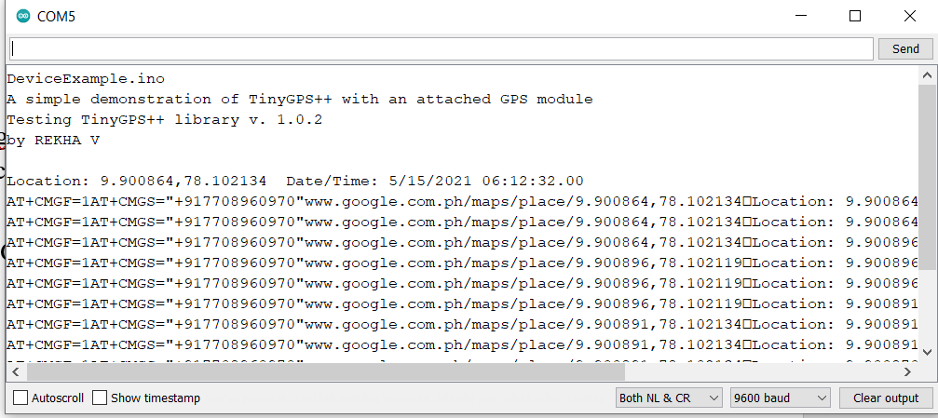

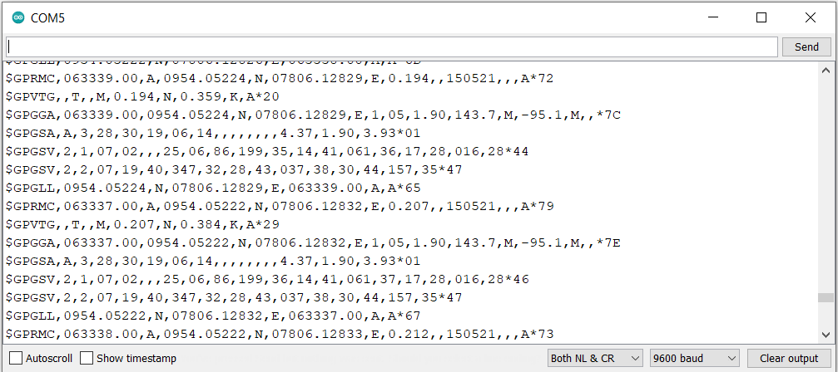

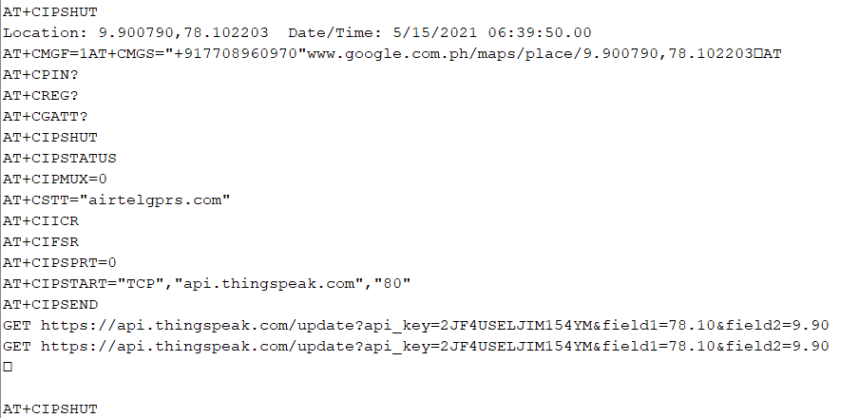



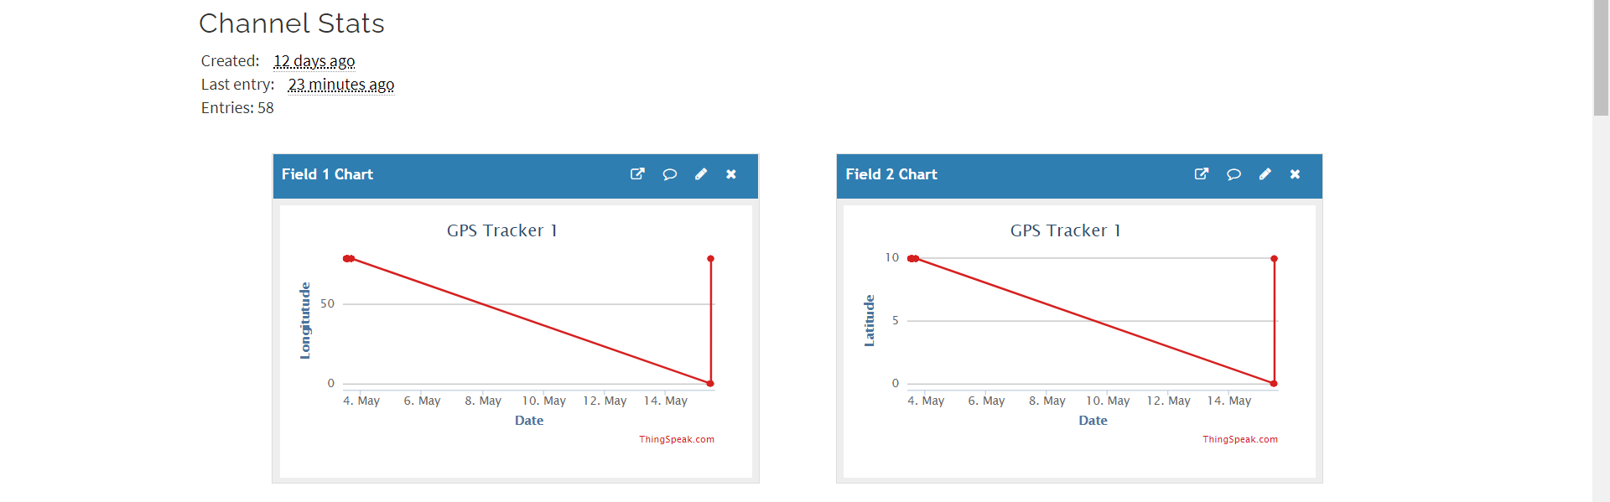

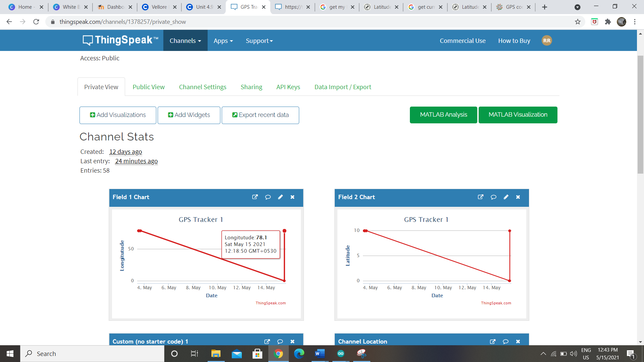

 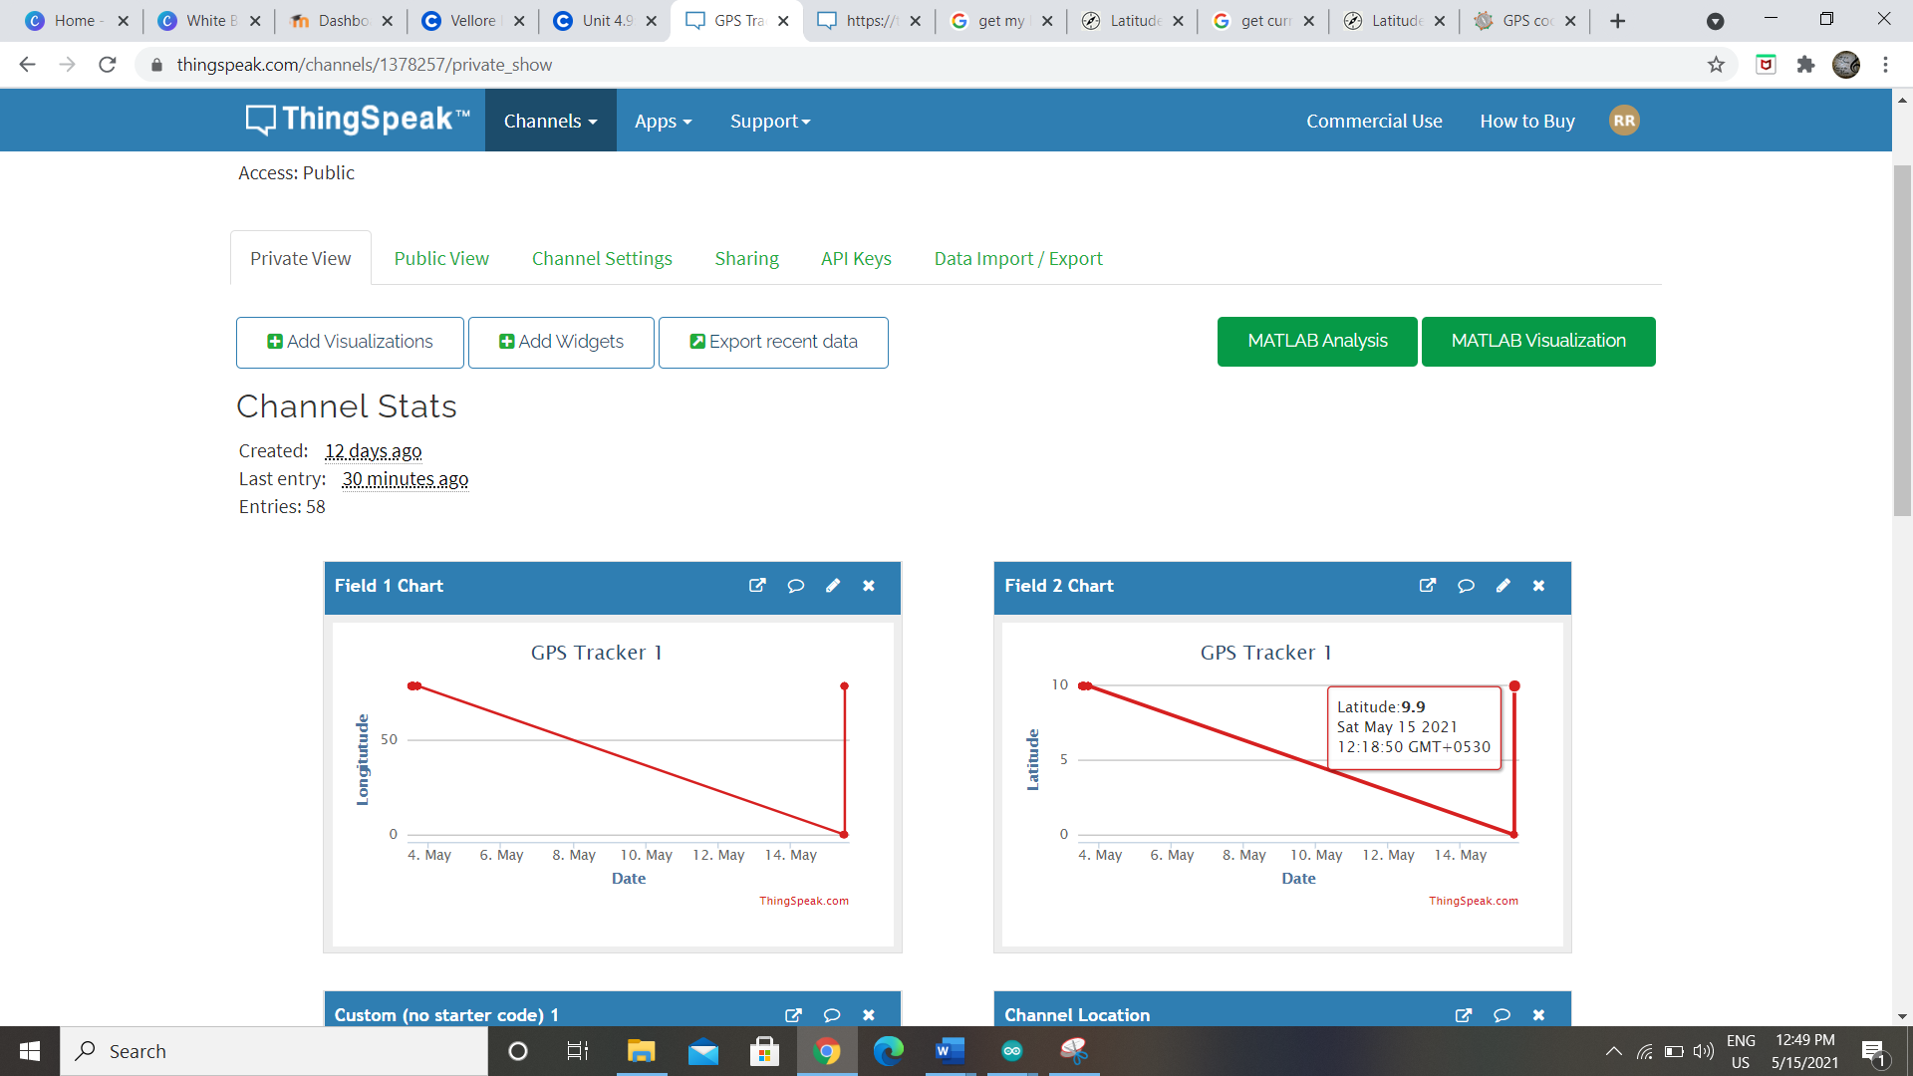

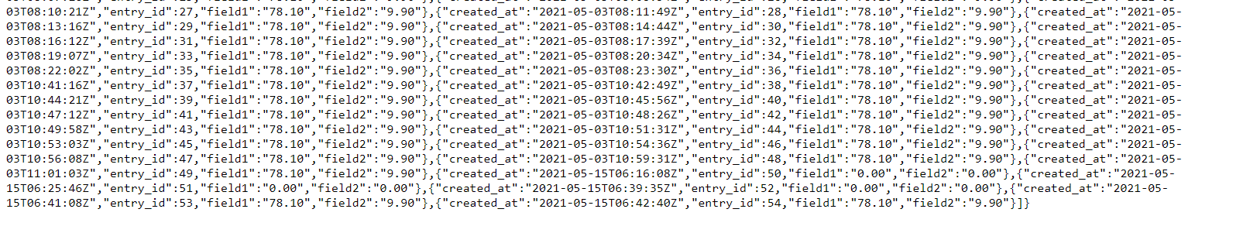

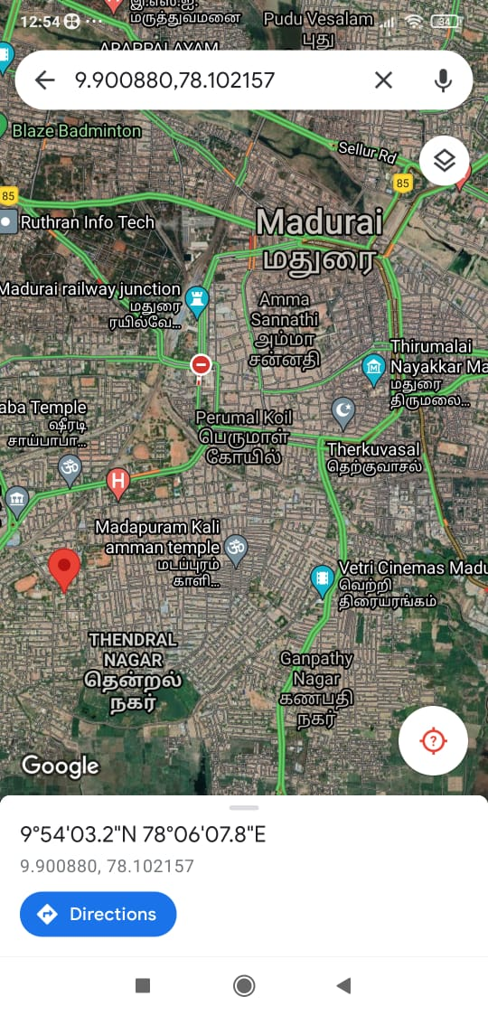



|  |  |
| --- | --- |
| Arduino | GPS module |
| Digital pin 10 | RX pin |
| Digital pin 11 | TX pin |
| VCC – 5v | VCC |
| Ground | Ground |

|  |  |
| --- | --- |
| Arduino | GSM module |
| Digital pin RX | TX pin |
| Digital pin TX | RX pin |
| VCC – 5v | VCC |
| Ground | Ground |